**Temperature -** Diagnostic Checking

**Time Series Plot**

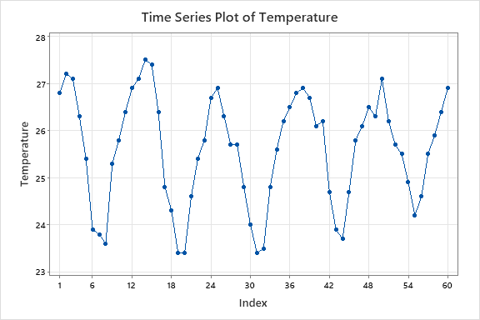

This is a seasonal with upward trend.

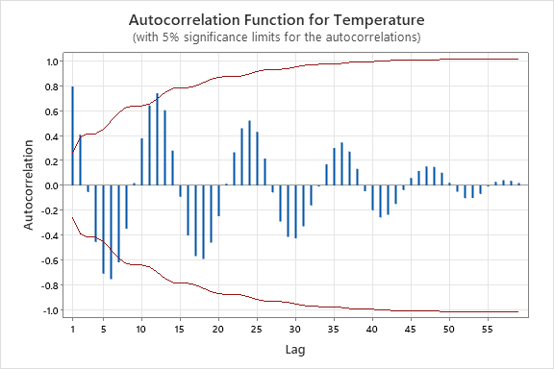

**Autocorrelations**

Lag ACF T LBQ

1 0.794075 6.15 39.76

2 0.406551 2.09 50.36 Non Seasonal area

3 -0.052746 -0.25 50.54

4 -0.453396 -2.18 64.20

5 -0.708092 -3.16 98.11

6 -0.751445 -2.91 137.01

7 -0.617413 -2.11 163.76

8 -0.347182 -1.11 172.39

9 0.019509 0.06 172.41

10 0.377168 1.18 183.00

11 0.643064 1.96 214.39

12 0.740968 2.13 256.94

24 0.519990 1.16 445.97 Seasonal area

36 0.344774 0.70 576.90

48 0.148844 0.29 646.87

Decision 1

Since ACF has a seasonal pattern, seasonal difference can be applied.

After doing a seasonal difference

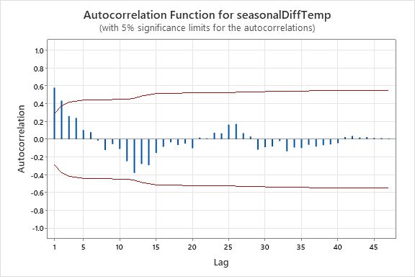

**Autocorrelations**

Lag ACF T LBQ

1 0.579912 4.02 17.17

2 0.434318 2.33 27.01

3 0.260519 1.26 30.63

4 0.240226 1.13 33.78

5 0.102530 0.47 34.37

6 0.079305 0.36 34.73

7 -0.015172 -0.07 34.74

8 -0.122642 -0.56 35.64

9 -0.054762 -0.25 35.83

10 -0.109636 -0.49 36.59

11 -0.246663 -1.10 40.53

12 -0.379890 -1.66 50.16

24 0.066592 0.26 66.22

36 -0.063437 -0.23 83.91

ACF cuts off at non seasonal lag 2. Therefore, seasonally difference series is stationary.

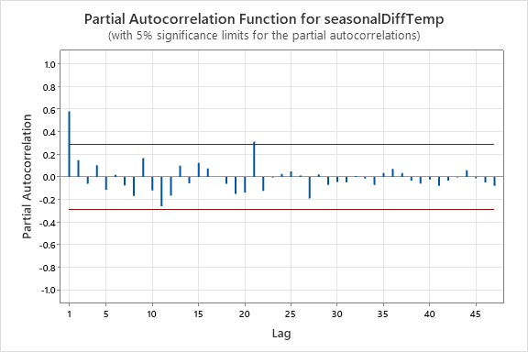

**Partial Autocorrelations**

Lag PACF T

1 0.579912 4.02

2 0.147687 1.02

3 -0.061296 -0.42

4 0.104125 0.72

5 -0.113248 -0.78

6 0.017296 0.12

7 -0.074880 -0.52

8 -0.168174 -1.17

9 0.165876 1.15

10 -0.119344 -0.83

11 -0.260102 -1.80

12 -0.166371 -1.15

24 0.025946 0.18

36 0.070317 0.49

PACF cuts off at non seasonal lag 1. (There is one spike value and we can ignore that)

Tentative Model 1: SARIMA (1,0,2)(0,1,0)

Decision 2:

Since ACF cuts off at seasonal lag 1 and ACF is significant in non seasonal area. Therefore, we can do a trend difference.

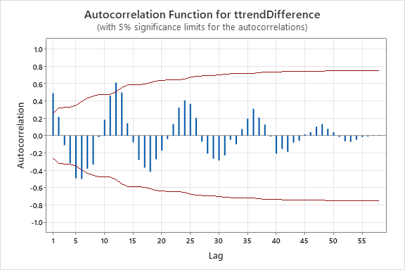

**Autocorrelations**

Lag ACF T LBQ

1 0.490873 3.77 14.95

2 0.216674 1.37 17.92

3 -0.109066 -0.67 18.68

4 -0.317628 -1.93 25.28

5 -0.490203 -2.81 41.30

6 -0.499581 -2.54 58.25

7 -0.381503 -1.76 68.32

8 -0.331856 -1.45 76.09

9 -0.016115 -0.07 76.11

10 0.184384 0.78 78.61

11 0.463182 1.94 94.69

12 0.613167 2.42 123.48

24 0.407489 1.24 217.56

36 0.309627 0.86 290.57

48 0.133855 0.36 332.59

Since ACF has a seasonal pattern, series is non stationary and apply seasonal difference for the trend seasonal series.

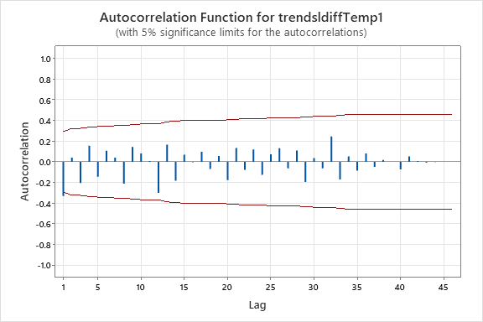

**Autocorrelations**

Lag ACF T LBQ

1 -0.329749 -2.26 5.44

2 0.040632 0.25 5.53

3 -0.203939 -1.27 7.71

4 0.155495 0.93 9.00

5 -0.143317 -0.84 10.13

6 0.108427 0.63 10.79

7 0.039854 0.23 10.88

8 -0.210499 -1.21 13.49

9 0.145004 0.81 14.77

10 0.081878 0.45 15.19

11 0.008334 0.05 15.19

12 -0.300791 -1.65 21.14

24 -0.125097 -0.60 34.83

36 0.080300 0.35 62.09

PACF cuts off at non seasonal lag 1. Therefore, seasonally differenced series is stationary.

Tentative Model 2: SARIMA(1,1,1)(0,1,0)

Tentative Model 1: SARIMA (1,0,2)(0,1,0)

Tentative Model 2: SARIMA(1,1,1)(0,1,0)

**Tentative Model 01:**

SARIMA(1,0,2)(0,1,0)

Diagnostic Checking

1. Significance of the parameter estimates

Hypothesis : H0 : All parameters = 0 vs All Parameters ≠ 0

**Final Estimates of Parameters**

|  |  |  |  |  |
| --- | --- | --- | --- | --- |
| **Type** | **Coef** | **SE Coef** | **T-Value** | **P-Value** |
| AR   1 | 0.674 | 0.250 | 2.70 | 0.010 |
| MA   1 | 0.161 | 0.284 | 0.57 | 0.574 |
| MA   2 | -0.064 | 0.205 | -0.31 | 0.755 |

Since the p-value > 0.05 for MA(1) and MA(2) parameters, they are not significant. Therefore, we have to revised the model.

When remove one MA term other MA term also not significant and therefore, MA(1) and MA(2) were removed from the tentative model.

Revised model: SARIMA(1,0,0)(0,1,0)

**Final Estimates of Parameters**

|  |  |  |  |  |
| --- | --- | --- | --- | --- |
| **Type** | **Coef** | **SE Coef** | **T-Value** | **P-Value** |
| AR   1 | 0.590 | 0.119 | 4.96 | 0.000 |

1. Randomness of residuals

Hypothesis : H0 : Residual ACF = 0 vs H1L : Residual ACF ≠0

**Modified Box-Pierce (Ljung-Box) Chi-Square Statistic**

|  |  |  |  |  |
| --- | --- | --- | --- | --- |
| **Lag** | **12** | **24** | **36** | **48** |
| Chi-Square | 14.25 | 23.11 | 43.65 | * |
| DF | 11 | 23 | 35 | * |
| P-Value | 0.220 | 0.454 | 0.150 | * |

Since all the p-values are greater than 0.095, null hypothesis is not rejected at 5% significance level. Therefore, residuals are random.

1. Normality of residuals

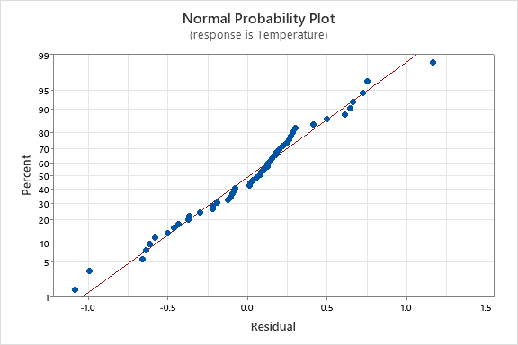

Normal Probability plot of residuals exhibits an approximately a straight line. Therefore, residuals are normally distributed

1. Parameter redundancy

Here, there is only one parameter, and parameter redundancy does not exist.

**SARIMA(1,0,0)(0,1,0) is an adequate model.**

**Tentative Model 02**

SARIMA(1,1,1)(0,1,0)

Diagnostic Checking

1. Significance of the parameter estimates

Hypothesis : H0 : All parameters = 0 vs All Parameters ≠ 0

**Final Estimates of Parameters**

|  |  |  |  |  |
| --- | --- | --- | --- | --- |
| **Type** | **Coef** | **SE Coef** | **T-Value** | **P-Value** |
| AR   1 | 0.683 | 0.121 | 5.66 | 0.000 |
| MA   1 | 1.0092 | 0.0160 | 63.26 | 0.000 |
|  |  |  |  |  |

Since the p-value < 0.05 for MA(1) and AR(1) parameters, they are significant. Therefore, we don’t have to revised the model.

1. Randomness of residuals

Hypothesis : H0 : Residual ACF = 0 vs H1L : Residual ACF ≠0

**Modified Box-Pierce (Ljung-Box) Chi-Square Statistic**

|  |  |  |  |  |
| --- | --- | --- | --- | --- |
| **Lag** | **12** | **24** | **36** | **48** |
| Chi-Square | 16.25 | 26.81 | 50.09 | * |
| DF | 10 | 22 | 34 | * |
| P-Value | 0.093 | 0.219 | 0.037 | * |
|  |  |  |  |  |

Since all the p-values are not greater than 0.095, null hypothesis is rejected at 5% significance level. Therefore, residuals are not random.

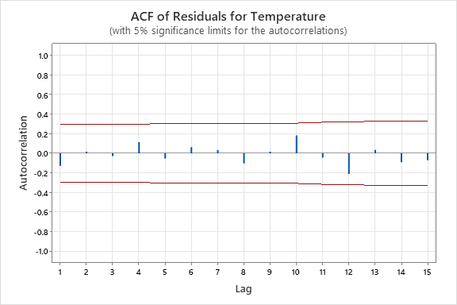

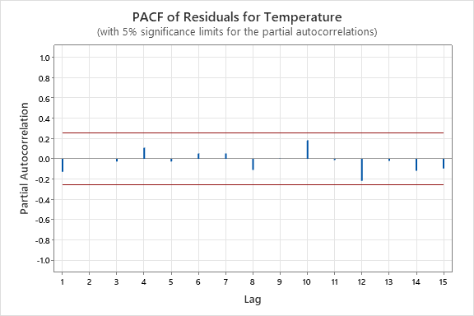

There are no cuts off pattern in ACF of residuals and PACF of residuals. Therefore, residuals are random.

1. Normality of Residuals

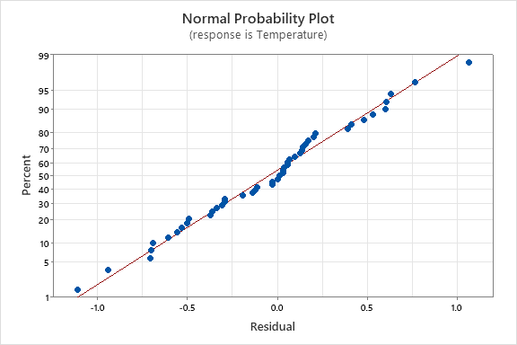

Normal Probability plot of residuals exhibits an approximately a straight line. Therefore, residuals are normally distributed

1. Parameter redundancy

Here, there is only one parameter, and parameter redundancy does not exist.